**Table of Contents**

CHAPTER 1 3

INTRODUCTION 3

1.1 Background of the Study 3

1.2 Problem Statement 4

1.3 Objectives of the Study 4

1.4 Significance of the Study 5

1.5 Scope and Limitations of the Study 5

1.6 Definition of Terms 6

1.7 Conceptual Framework 8

1.8 Theoretical Framework 9

1.8.1 Battery Monitoring 9

1.8.2 Motor Sizing 10

1.8.3 Rudder Servo Sizing 11

CHAPTER 2 12

REVIEW OF RELATED LITERATURE 12

2.1 Water Waste 12

2.2 Water Waste Collection 12

2.2.1 Alpha Boats 12

2.2.2 Trash Collection Skimmer Boat 13

2.3 Development of Unmanned Surface Vehicles 14

Real-Time Water Quality Monitoring for Small Aquatic Area Using Unmanned Surface Vehicle 15

WasteShark 15

Interceptor 16

2.4 Control System of Unmanned Surface Vehicles 18

CHAPTER 3 20

METHODOLOGY 20

3.1 Firmware Design Process 20

3.1.1 Battery Monitoring 21

3.1.2 Maneuvering and Camera Movement 21

3.1.3 Global Positioning System (GPS) Module 22

3.1.4 Inertial Measurement Unit (IMU) 22

3.1.5 Transceiver Module 22

3.2 Hardware Design Process 22

3.2.1 EasyEDA 23

3.3 Software Design Process 24

3.4 Test and Evaluation 24

REFERENCES 25

# CHAPTER 1

# INTRODUCTION

## Background of the Study

The Philippine Archipelago has approximately 7000 islands located in the Western Pacific. The Philippines, as a country surrounded by water, is one of the highest contributors of plastic waste in the marine environment. Data shows that the country contributes 0.28-0.75 million metric tons of plastic per year (Jambeck et al., 2015).

Plastics scattered throughout the ocean which subsequently resulted in different patches. Chemicals from plastics are spread into the atmosphere as well as the water that are damaging to humans. Chemicals from plastics like lead, cadmium, and mercury, in direct contact with humans, are dangerous which are associated with cancer, birth defects and immune system problems (Andrews, 2012).

Actions are taken to battle pollution in marine environments. Emerging technology for waste collection has been developed for the past few years. Alpha Boats, developed in New York have been used for trash and debris operations(AlphaBoats, n.d.). Trash skimmer boats, an invention by Stephen Walcyzk, works for collecting and disposing of solid waste materials in surface waters. These machines run with humans on board for operation and control (Walczyk, 2004).

With unmanned system technology, recent studies show successful machines with no humans on board. An example of the unmanned system is unmanned surface vehicles. Applications using this system are attained during the last few years of research and study; Water Quality Monitoring using USV (Demetillo & Taboada, 2019), WasteShark for solid waste collection (Swan, 2018), Interceptor for autonomous waste collection (Ocean CleanUp, 2019). Using an unmanned surface vehicle, an efficient method as an alternative for dangerous operation and collection of waste without onboard human presence can be achieved.

## Problem Statement

Situations in a dangerous environment often involve high-risk operation that needs human intervention. There is a need for a system to operate without a human onboard to ensure the welfare of the operator while running the machine. The researchers aim to develop a control system and a human-machine interface for an Unmanned Surface Vehicle.

## Objectives of the Study

This research aims to develop a control system and a human-machine interface for an Unmanned Surface Vehicle for water waste collection. The study aims to:

1.) To implement a control system for USV

2.) To design and fabricate a controller shield for the control system

3.) To create a software application for monitoring and control

## Significance of the Study

The technology of unmanned systems takes the edge over manned systems in some areas. Unmanned systems execute in high-risk operations than manned vehicles with lower production and maintenance costs. With no humans on board, safety and loading capacity is considerably greater (Liu, Zhang, Yu, & Yuan, 2016).

Despite the proliferation of research on unmanned systems, the focus of researchers and companies for the past years is notably to unmanned aerial and ground vehicles than unmanned surface vehicles with about two-thirds of the earth’s surface is covered in water (Mancini, Frontoni, & Zingaretti, 2015). Development and demonstration of competent USVs have been observed recently (Manley, 2016).

As a country surrounded by water, the Philippines contributes significantly to water waste (Jambeck et al., 2015). Development of a system capable of receiving and sending data with no humans on board can aid in environmental missions such as the collection of water waste, bathymetry, and water monitoring.

## Scope and Limitations of the Study

This study focuses on implementing a control system for an unmanned surface vehicle for water waste collection. A controller shield for the control system will then be designed and fabricated. In addition, a human-machine interface will be created for data monitoring and control. The hardware components will be mounted on a (1.22m x 0.84m) catamaran hull. This will serve as a prototype of USV for water waste collection. The scope area of this study is on water bodies in the Philippines.

## Definition of Terms

A **catamaran** is a multi-hulled watercraft featuring two parallel hulls of equal size. It is a geometry-stabilized craft, deriving its stability from its wide beam, rather than from a ballasted keel as with a monohull sailboat. The catamaran is from a Tamil word, kattumaram, which means "logs tied together".

An **Electronic Speed Controller (ESC)** is a device that regulates the power of an electric motor, allowing it to throttle from 0% to 100%. There are two styles of Electronic Speed Controller, Brushed and Brushless.  A **brushed motor** can have its speed controlled by varying the voltage on its armature. A **brushless motor** requires a different operating principle. The speed of the motor is varied by adjusting the timing of pulses of current delivered to the several windings of the motor.

The **Global Positioning System (GPS)** is a satellite-based navigation system made up of a network of 24 satellites placed into orbit by the U.S. Department of Defense. GPS was originally intended for military applications, but in the 1980s, the government made the system available for civilian use. GPS works in any weather conditions, anywhere in the world, 24 hours a day. There are no subscription fees or setup charges to use GPS.

**The human-machine interface (HMI)** is a component of certain devices that are capable of handling human-machine interactions. The interface consists of hardware and software that allow user inputs to be translated as signals for machines that, in turn, provide the required result to the user. Human-machine interface technology has been used in different industries like electronics, entertainment, military, medical, etc. Human-machine interfaces help in integrating humans into complex technological systems. **MATLAB GUI** (also known as a graphical user interface or UI) provides point-and-click control of software applications, eliminating the need to learn a language or type commands in order to run the application.

An **Inertial Measurement Unit (IMU)** is an electronic device that measures and reports a body's specific force, angular rate, and sometimes the orientation of the body, using a combination of accelerometers, gyroscopes, and magnetometers. The data obtained can be used to derive the three special axes in any ship. **Roll** (Longitudinal/X-Axis)  is an imaginary line running horizontally through the length of the ship, through its center of gravity, and parallel to the waterline. A roll motion is a side-to-side or port-starboard tilting motion of the superstructure around this axis, **Pitch** (Transverse/Y-Axis) is an imaginary line running horizontally across the ship and through the center of gravity. A pitch motion is an up-or-down movement of the bow and stern of the ship, and **Yaw** (Vertical/Z-Axis)  is an imaginary line running vertically through the ship and through its center of gravity. A yaw motion is a side-to-side movement of the bow and stern of the ship.

**Pulse-width modulation (PWM)** is a modulation process or technique used in most communication systems for encoding the amplitude of a signal right into a pulse width or duration of another signal, usually a carrier signal, for transmission. Although PWM is also used in communications, its main purpose is actually to control the power that is supplied to various types of electrical devices, most especially to inertial loads such as AC/DC motors.

**MATLAB** combines a desktop environment tuned for iterative analysis and design processes with a programming language that expresses matrix and array mathematics directly. It includes the Live Editor for creating scripts that combine code, output, and formatted text in an executable notebook.

**A microcontroller** is an integrated chip that is often part of an embedded system. It includes a CPU, RAM, ROM, I/O ports, and timers like a standard computer, but because they are designed to execute only a single specific task to control a single system, they are much smaller and simplified so that they can include all the function required on a single chip.

A device that detects and responds to some type of input from the physical environment is called a **Sensor**. The specific input could be light, heat, motion, moisture, physical environment. The specific input could be light, heat, motion. moisture, pressure, or anyone of a great number of other environmental phenomena. The output is generally a signal that is converted to a human-readable display at the sensor location or transmitted electronically over a network for reading or further processing.

## Conceptual Framework

In this research, the overall design of the system consists of two main parts: the computer and the USV. Both parts communicate with each other through wireless communication with each part consisting of different subgroups that are integrated together to perform the functions of remote-operated USV.

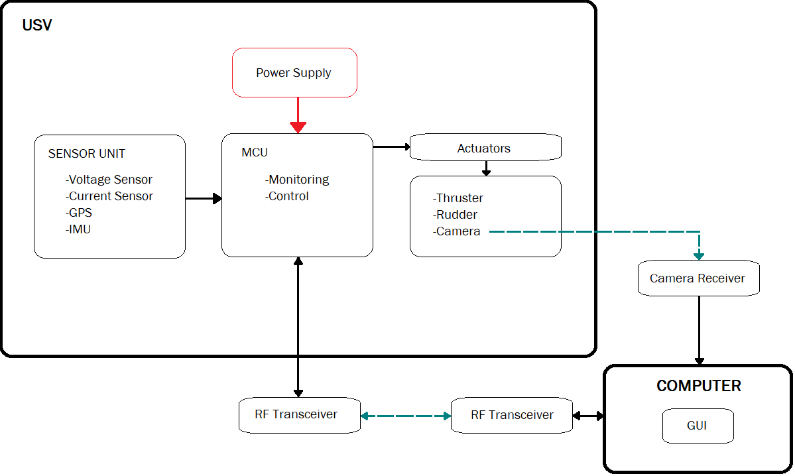

Figure 1.7.1 Conceptual Framework

## Theoretical Framework

##### Battery Monitoring

In order to monitor the battery, the State of Charge will be determined. Two methods: namely, Voltage Method and Coulomb Counting Method will be used to measure the battery's State of Charge. This will require reading data from voltage and current sensors.

The voltage method converts a reading of the battery voltage to the equivalent SOC value using the known discharge curve (voltage vs. SOC) of the battery (Murnane & Ghazel, 2017). To get the battery voltage, a voltage divider equation will be used:

$V_{batt}= \frac{R_{1}+R_{2}}{R_{1}} × V_{sense}$ Eq. 0.1.8.1

Where, R1=Resistor 1, R2= Resistor 2 and Vbatt = Voltage Level of the battery

Data from voltage sensors will be used only for initialization purposes. Acquiring, state-of-charge by voltage is simple, but since temperature and cell materials affect the voltage, it can be inaccurate (Buchmann, 2019). That is why Coulomb counting will be used to update the new values of SOC.

${SoC}_{new}\%= {SoC}_{old}-\left(\frac{I ×time}{AH}\right)×100$ Eq. 1.8.2

Where, old

I = current sensed by the sensor every second

$time= \frac{1 min}{60 sec}×\frac{1 hr}{60 min}$ Eq. 1.8.3

AH= the amp-hour rating of the battery that will be used

##### Motor Sizing

For motor sizing of the USV, the relationship between motor angular velocity[rad/s], torque [Nm] and power [W] will be considered.

$P_{m}= T_{m}×ω_{m}$ Eq. 1.8.4

$m_{v}∙ u= \sum{F_{drag}}+F_{thrust}$ Eq. 1.8.5

$\frac{P_{R}}{ω_{m}∙r_{m }∙χ}- \sum{F_{drag}}= m_{v}∙ u$ Eq. 1.8.6

Where ωm is the motor angular velocity, rm is the radius of action of the motor, Pr[W] is the necessary real power of the motor, $\sum{F_{drag} }$ is the sum of all the drag forces in the surge direction. χ [+]  is the performance coefﬁcient (Borreguero, Velasco, & Valente, 2018).

##### Rudder Servo Sizing

According to (Borreguero et al., 2018), rudder action will orient the USV which is executed by a servo motor. Concerning its sizing, the forces produced over the surface of the rudder in operation will be considered. With the distribution of pressures on its surface, the force exerted can be calculated:

$F_{Rudder}= \int_{0}^{L}{ρg(L_{rudd}-Z)}∙bdz$ Eq. 1.8.7

Where g[m/s2] is gravitational acceleration, b[m] is the width, LRudd[m] is the rudder length, and z[m] the vertical that corresponds to the height in a cartesian coordinate system. Through the rudder action raction [m]radius, the torque Trudder exerted by the servo is expressed by:

$T_{Rudder }= F_{Rudder}∙ r_{action}$ Eq. 1.8.8

# CHAPTER 2

# REVIEW OF RELATED LITERATURE

### Water Waste

Pollution finds ways into different marine environments. According to a study, about 5 trillion pieces weighing over 260, 000 tons of plastic spread throughout the oceans.  Accumulation of waste in the oceans results in potential damage to marine life and humans (Andrews, 2012).

### Water Waste Collection

With the alarming number concerning the amount of plastic produced and spread throughout the marine environment, proper waste management including waste collection is needed. In this section, machines developed for water waste collection are discussed.

#### Alpha Boats

Alpha Boats, a company in New York that produces vehicles for water management, has been a worldwide manufacturer of equipment for waste collection on water. One example is the marina cleaner shown in Figure 2.2.1.

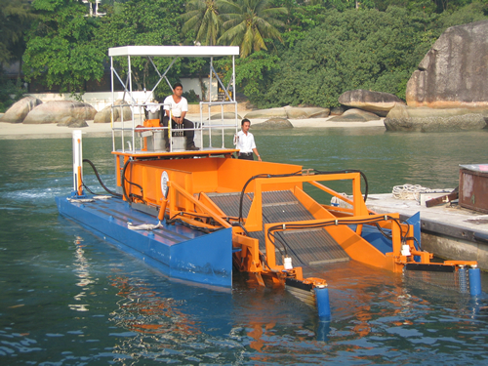

Figure 2.2.1 Marina Cleaner

The marina cleaner has a front pick-up conveyor able to collect large to small sizes of garbage. The design also has a short vertical clearance for movement under bridges. (AlphaBoats, n.d.)

#### Trash Collection Skimmer Boat

The trash collection skimmer boat invented by Stephen Walczyk works as an effective vehicle for the collection and discharge of floating debris. The machine is run by an operator in an elevated area above the boat hull. The operator can control the navigation of the vehicle. Furthermore, the operator can manage the movement of the conveyor (Walczyk, 2004). Figure 2.2.2 shows the drawing for the trash collection skimmer boat.

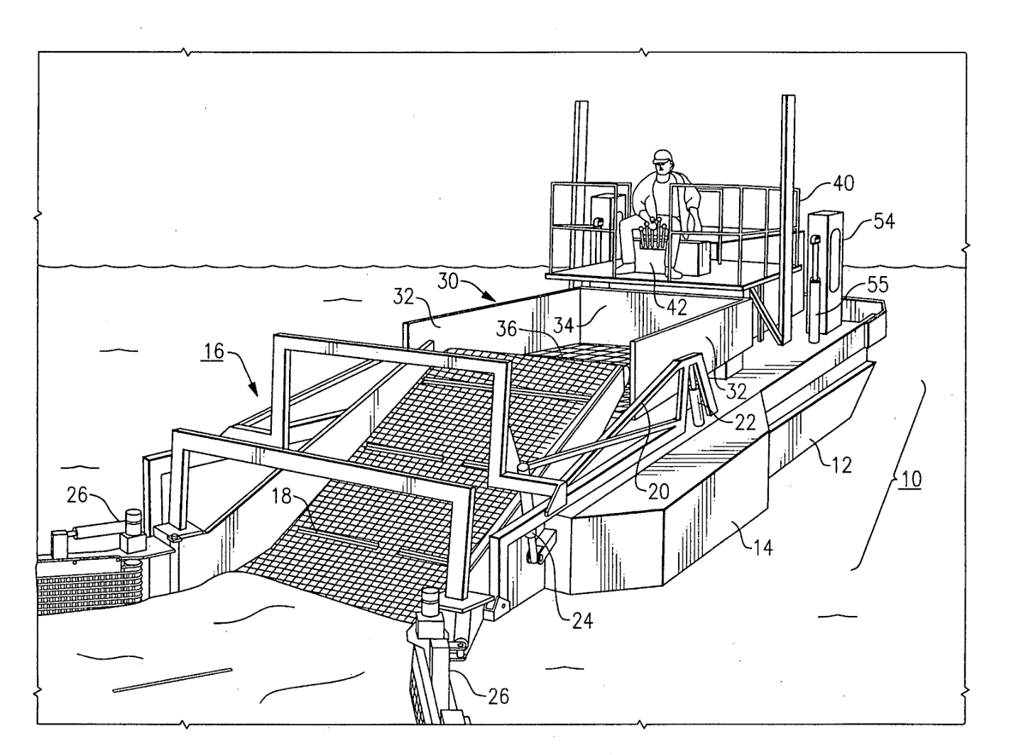

Figure 2.2.2 Trash Collection Skimmer Boat

Water waste collection can be managed and successfully be implemented with these manned machines. However, with the progress of technology over time, improvement of manned vehicles can be observed through the development of unmanned systems.

### Development of Unmanned Surface Vehicles

Water waste collection can be managed and successfully be implemented with these manned machines. However, with the progress of technology over time, improvement of manned vehicles can be observed through the development of unmanned systems.

###### Real-Time Water Quality Monitoring for Small Aquatic Area Using Unmanned Surface Vehicle

The need for real-time data acquisition for water quality monitoring is increasing because of its efficiency, and accuracy. The researcher created a low-cost unmanned surface vehicle of water quality monitoring for small aquatic areas.  The USV has a water quality sensor as its primary component. It was designed to operate autonomously or remotely operated depending on the location of the area. Water temperature and pH were measured by the sensors that were connected to the Arduino Mega 2560 Microcontroller. The real-time data were sent to the ground station using the Xbee transceiver module for short-distance transmission and GSM/GPRS transceiver for long-distance transmission. The received real-time data were then logged to the designed USV data logger developed using Visual Studio. The USV was tested to conduct a water quality testing mission with a pre-inputted route and the USV performed well in data transmission and navigation. With the successful implementation of the USV,  the system can enhance information dissemination on the quality status of the water (Demetillo & Taboada, 2019).

###### WasteShark

A drone technology company from the Netherlands, RanMarine Technology, developed an aquadrone that “eats” unwanted plastic, alien/pest flora, and other litters from the water surface. This aquadrone is called the WasteShark™. Shaped like a shark with an open wide mouth, it measures 1.5 meters by 1.1 meters, produces zero greenhouse emissions and can carry up to 159.6kg of trash (Swan, 2018). It was designed for use especially in harbors and ports.

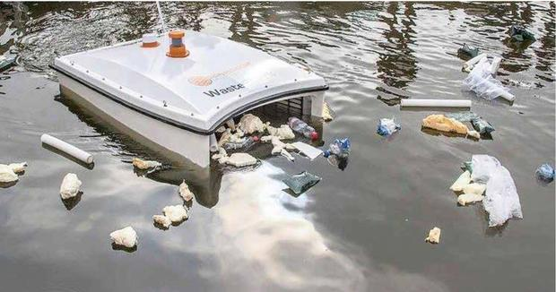

The WasteShark is currently operating in Netherlands, Dubai and some parts in South Africa. It is available in two (2) models, a remote-controlled model costs around $17,000 and the autonomous model cost just under $23,000 (Swan, 2018).

Aside from its expensive price, its size is also of concern. An NYU Abu Dhabi professor of biology, John Burt, said that "In terms of the units that are currently being deployed, I think they're relatively small and going to have a minor impact. But if it's proof of concept for the principle, then potentially it could be used on a larger scale,".

###### Interceptor

An environmental organization founded by Boyan Slat based in Netherland, the Ocean Cleanup introduced an autonomous system for river plastic waste. It is a pioneering scalable invention that prohibits waste from rivers to enter the oceans, hence being called the *Interceptor* (Ocean CleanUp, 2019).

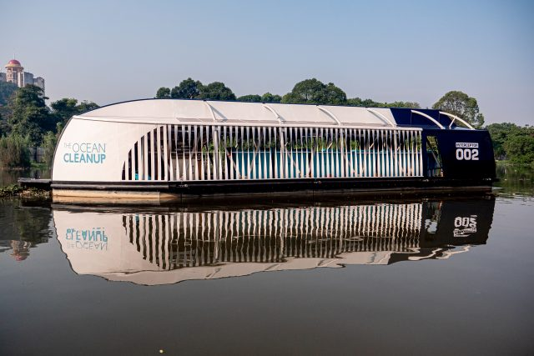

Figure 2.3.1 The Interceptor in a river in Malaysia

The machine, with the size of 8m x 24m x 5m, has the capacity of 50 cubic meters, having the conveyor belt extraction rate of 24kg/s can pull out autonomously 50,000 kilograms of waste per day. It is powered by solar energy with a capacity of 5.6 kWp and with a battery capacity of 20 kWh Li-on.

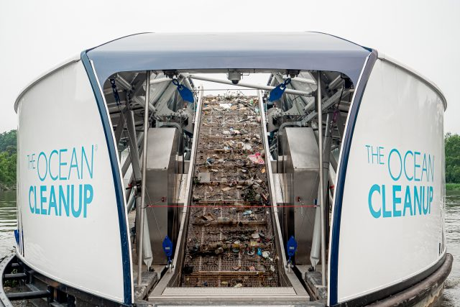

Figure 2.3.2 Inside the Interceptor

### Control System of Unmanned Surface Vehicles

Developed a modular unmanned Surface vehicle for research and educational purposes. They presented an integrated multi-level control design consists of Control and Communication (C&C) Level, Navigation Level, and Drive Level so that students can modify and develop their own algorithm one at a time. The components connected to (C&C) Level were the radio modem, GPS module, and the weather sensors, while the Navigation Level had an IMU connected to it and lastly the Drive Level consists of ESC(Electronic Speed Controller), Servos, water pump and temperature sensors. The multi-level control design communicate via I2C(Inter-Integrated Circuits) protocol. The proposed USV can operate autonomously or can be controlled remotely over wireless radiolink. Each component can be modified according to a specific application and environmental conditions making it a highly modular design (Vasilj, Stancic, Grujic, & Music, 2017).

Researchers presented a study on the controller design of the surface cleaning robot. The robot’s propulsion control system was designed based on the principle of PWM  speed control (Yuyi, Yu, Huanxin, Yunjia, & Liang, 2013). A stepper motor was installed for the garbage collection and 2 DC motors w, 1 for each hull for the propulsion system. It will be powered by a battery and solar photovoltaic panels. The robot can perform forward, backward, left, and right maneuvers according to the command sent by a host computer. The robot can perform cleaning operation activities and can achieve good control effects.

# CHAPTER 3

# METHODOLOGY

This chapter details the design and methods that will be used to meet the objectives set for this study. Content is arranged into four (4) sections: the first section discusses the firmware design process; the second section explains the hardware design process; the third section shows the software design process; the fourth section tackles the testing and evaluation process. Algorithms that are hitherto unspecified will be defined as they are introduced and discussed in this chapter.

1. Firmware Design Process

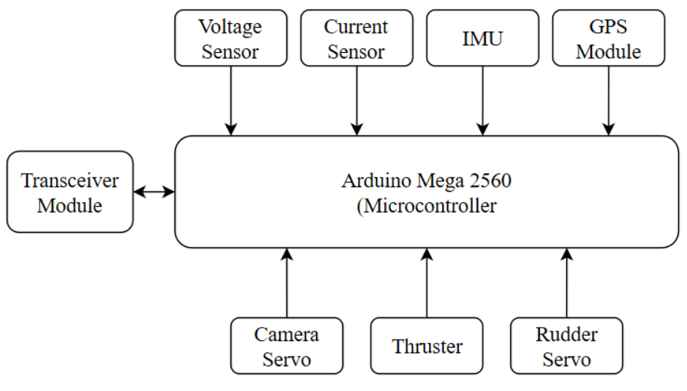

Figure 3.2 Firmware Design

1. Battery Monitoring

Voltage Sensor module and Current Sensor module will be used to measure the voltage and the current that flows out from the battery. The output of the modules will be connected to the analog pins of the microcontroller. The analog readings will then be used to calculate the actual voltage and current. The State of Charge of the battery will then be obtained by approximation.

1. Maneuvering and Camera Movement

The drive module of the USV consists of a single 3650 4300KV Motor 60A Brushless  Motor controlled by ESC( Electronic Speed Controller ) based on PWM(Pulse Width Modulation) principle for the thruster. Dynamixel AX-12 Servo will be used for the rudder and for the waste collection conveyor. For camera movements, the camera will be attached to a servo motor that can move up to 150 degrees. The data pins of the following motors will be connected to digital/PWM pins of the microcontroller. The motors will be programmed to respond accordingly every time the user sends a command to tilt the camera, to maneuver the USV and to begin the waste collection operation.

1. Global Positioning System (GPS) Module

For the GPS module,  location data in NMEA format will be received from the module through software serial communication and will be parsed to get the geodetic location of the module every second. Latitude, longitude, time, velocity and heading course will then be sent serially to the ground controller.

1. Inertial Measurement Unit (IMU)

The 9-DOF Accelerometer, 3-axis accelerometer, gyroscope, and a magnetometer will be used to estimate the orientation, position, and acceleration of the USV. The acceleration and angular velocity will be obtained from the IMU module through the inter-integrated circuit (I2C) communication. The Euler angles, roll, pitch, and yaw will be computed in and will be sent through serial communication.

1. Transceiver Module

For wireless communication, a transceiver module will be connected to the MCU and the other one for the ground station. Command signal will be sent from the ground station and the sensor data from the USV will be sent to the ground station through this transceiver module.

1. Hardware Design Process

The catamaran watercraft will be modeled and produced by Manuel Chad Agurob, Muhammad-Ali Dimapalao, and Jeff Riveral Gorre, students of doctor of engineering program in MSU-IIT.  The circuit of the control system will be placed on top of the hull of the watercraft. Figure 3.2.1 shows the block diagram of the circuit of the control system. The figure shows an overview of the control system to be used in the surface vehicle.

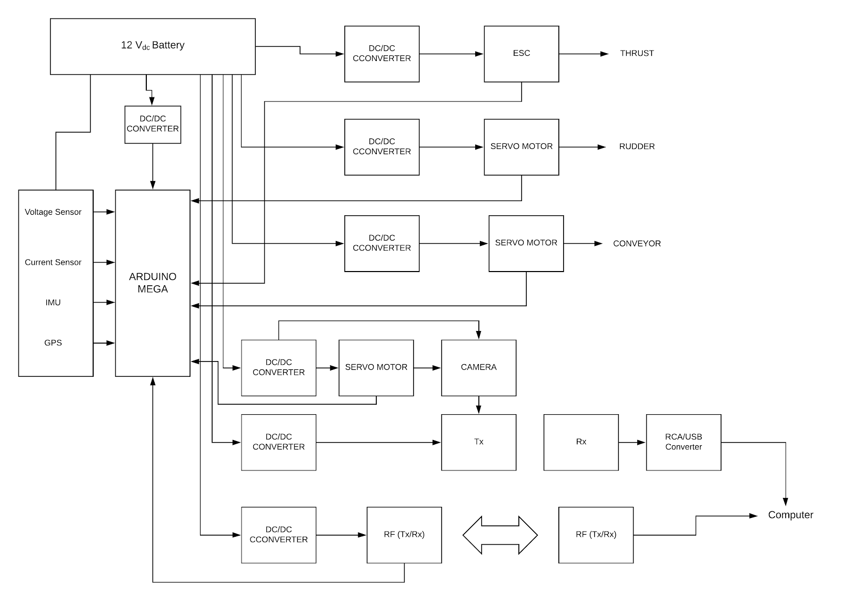

Figure 3.2.1 Block Diagram of the Control System

1. EasyEDA

For the design of the controller shield, a web-based electronics design automation tool can be used. EasyEDA is a free software package that enables the user to create a schematic design, circuit simulation, and PCB layout. The circuits to be used for the control system will be connected in a single controller shield. The software will be used for the design of the circuit controller shield and PCB layout. The designed PCB layout will then be fabricated.

1. Software Design Process

In order to make the USV easy to operate, the use of a graphical user interface would be of great assistance. The existence of controls such as menus, toolbars, buttons, and sliders in MATLAB GUI makes it convenient for a wide range of applications. In this project, the MATLAB GUI will be used to implement the software application for monitoring and control.

1. Graphical User Interface

The graphical user interface design will consist of user control panels, video frame, IMU graphs and GPS mapping. It will have additional features: namely,  signal strength, battery status and time. A special button will also be provided to allow the user to capture images from the video frame. The captured images will be saved into a designated file.

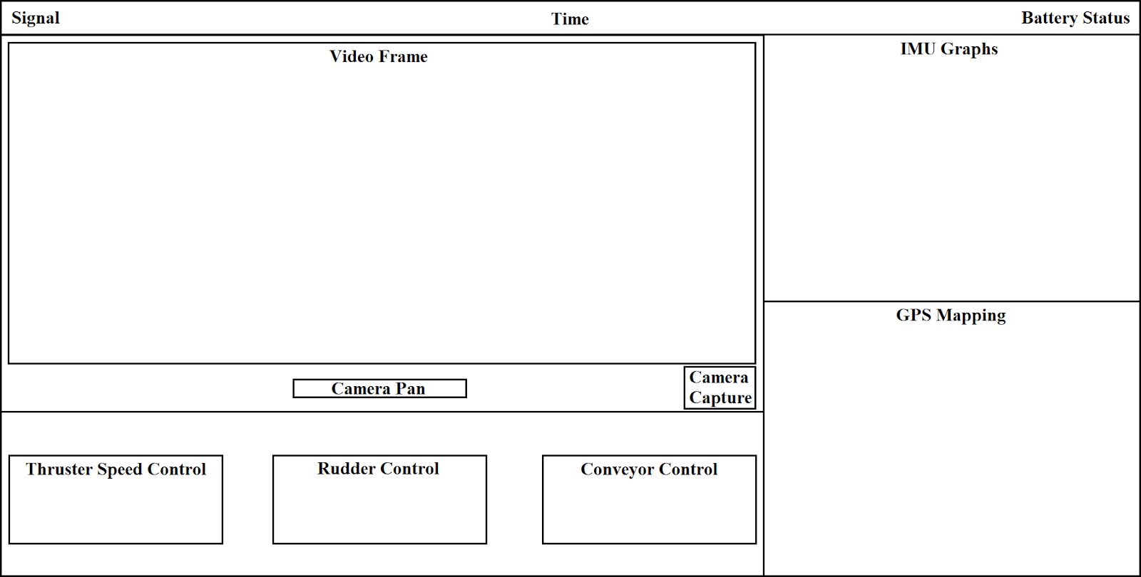

Figure 3.3.1 Human-Machine Interface

1. Test and Evaluation

In order to correctly evaluate the performance of the USV system, the sensors and control units will undergo evaluation tests. In these tests, at least three (3) attributes would be measured: namely, sensitivity, accuracy, and precision.

For the sensors, its sensitivity or the ability of the sensors to transmit changes in measurements in the quickest amount of time will be tested. The ability of the sensors to give a true measurement, its accuracy, and its ability to give consistent results, its precision, are good measures to ensure valid data acquisition. The data provided by the sensors will be compared with actual data measured from reliable devices. Then, the mean percentage of errors will be calculated.

For the control units, its responsiveness to the command of the user, the ability to perform according to the task and give consistent results will be tested.

###### REFERENCES

AlphaBoats. (n.d.). AlphaBoats Website - AlphaBoats Website. Retrieved November 20, 2019, from https://alphaboats.com/

Andrews, G. (2012). Plastics in the Ocean Affecting Human Health. Retrieved November 22, 2019, from https://serc.carleton.edu/NAGTWorkshops/health/case_studies/plastics.html

Borreguero, D., Velasco, O., & Valente, J. (2018). Experimental design of a mobile landing platform to Assist Aerial Surveys in fluvial environments. *Applied Sciences (Switzerland)*, *9*(1). https://doi.org/10.3390/app9010038

Buchmann, I. (2019). Measuring State-of-charge - Battery University. Retrieved November 22, 2019, from https://batteryuniversity.com/learn/article/how_to_measure_state_of_charge

Demetillo, A., & Taboada, E. (2019). Real-Time Water Quality Monitoring For Small Aquatic Area Using Unmanned Surface Vehicle. *Engineering, Technology & Applied Science Research*, *9*(2), 3959–3964. https://doi.org/10.5281/zenodo.2647809

Jambeck, J. R., Ji, Q., Zhang, Y.-G., Liu, D., Grossnickle, D. M., & Luo, Z.-X. (2015). Plastic waste inputs from land into the ocean. *Science*, *347*(6223), 764–768. https://doi.org/10.1126/science.1260879

Liu, Z., Zhang, Y., Yu, X., & Yuan, C. (2016). Unmanned surface vehicles: An overview of developments and challenges. *Annual Reviews in Control*, *41*, 71–93. https://doi.org/10.1016/j.arcontrol.2016.04.018

Mancini, A., Frontoni, E., & Zingaretti, P. (2015). Development of a low-cost Unmanned Surface Vehicle for digital survey. *2015 European Conference on Mobile Robots, ECMR 2015 - Proceedings*. https://doi.org/10.1109/ECMR.2015.7324189

Manley, J. E. (2016). Unmanned Maritime Vehicles, 20 years of commercial and technical evolution. *OCEANS 2016 MTS/IEEE Monterey, OCE 2016*, 1–6. https://doi.org/10.1109/OCEANS.2016.7761377

Murnane, M., & Ghazel, A. (2017). A Closer Look at State of Charge (SOC) and State of Health (SOH) Estimation Techniques for Batteries. *Analog Devices*. Retrieved from http://www.analog.com/media/en/technical-documentation/technical-articles/A-Closer-Look-at-State-Of-Charge-and-State-Health-Estimation-Techniques-....pdf

Ocean CleanUp. (2019). Rivers | The Ocean Cleanup. Retrieved November 19, 2019, from https://theoceancleanup.com/rivers/

Swan, E. (2018). Trash-eating “shark” drone takes to Dubai marina - CNN. Retrieved November 22, 2019, from https://edition.cnn.com/2018/10/30/middleeast/wasteshark-drone-dubai-marina/index.html

Vasilj, J., Stancic, I., Grujic, T., & Music, J. (2017). Design, Development and Testing of the Modular Unmanned Surface Vehicle Platform for Marine Waste Detection. *Journal of Multimedia and Information Systems*, *4*(December), 195–204. https://doi.org/10.9717/JMIS.2017.4.4.195

Walczyk, S. (2004). US20060065586A1 - Trash collection skimmer boat - Google Patents. Retrieved November 20, 2019, from https://patents.google.com/patent/US20060065586

Yuyi, Z., Yu, Z., Huanxin, L., Yunjia, L., & Liang, L. (2013). Control system design for a surface cleaning robot: Regular paper. *International Journal of Advanced Robotic Systems*, *10*, 1–5. https://doi.org/10.5772/56200